ASSIGNMENT 20

Name : Akanksha Joshi

Roll No : B038

Batch : 3

Div : BTech CS B

--------------------------------------------------------------------------------------------------------------------------

Write a Python program to generate ﬁrst 'n' Fibonacci numbers where 'n' is accepted as an input from the user.

Store the generated Fibonacci numbers in a list and display the output.

Sample input: 5

Sample output: [0, 1, 1, 2, 3]

Source Code

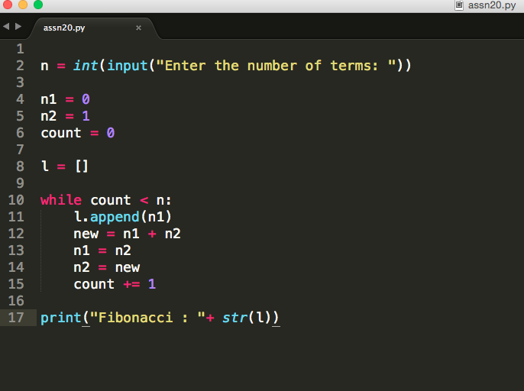

Output

Enter the number of terms: 10

Fibonacci : [0, 1, 1, 2, 3, 5, 8, 13, 21, 34]